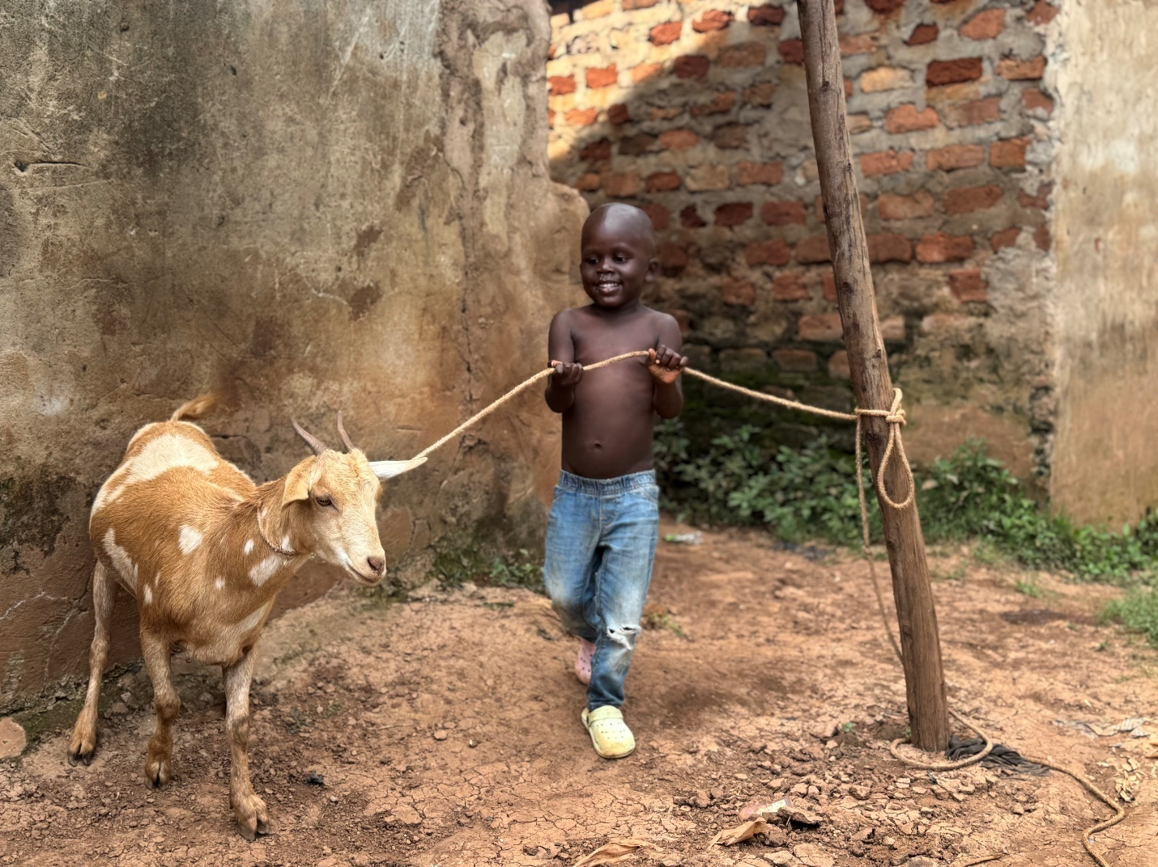

**Use the above as the cover photo, I don’t know if there’s a way you can blur his chest so that we don’t get sued for indecent exposure. If its not possible, use the one below. I am attaching both in clear version.**

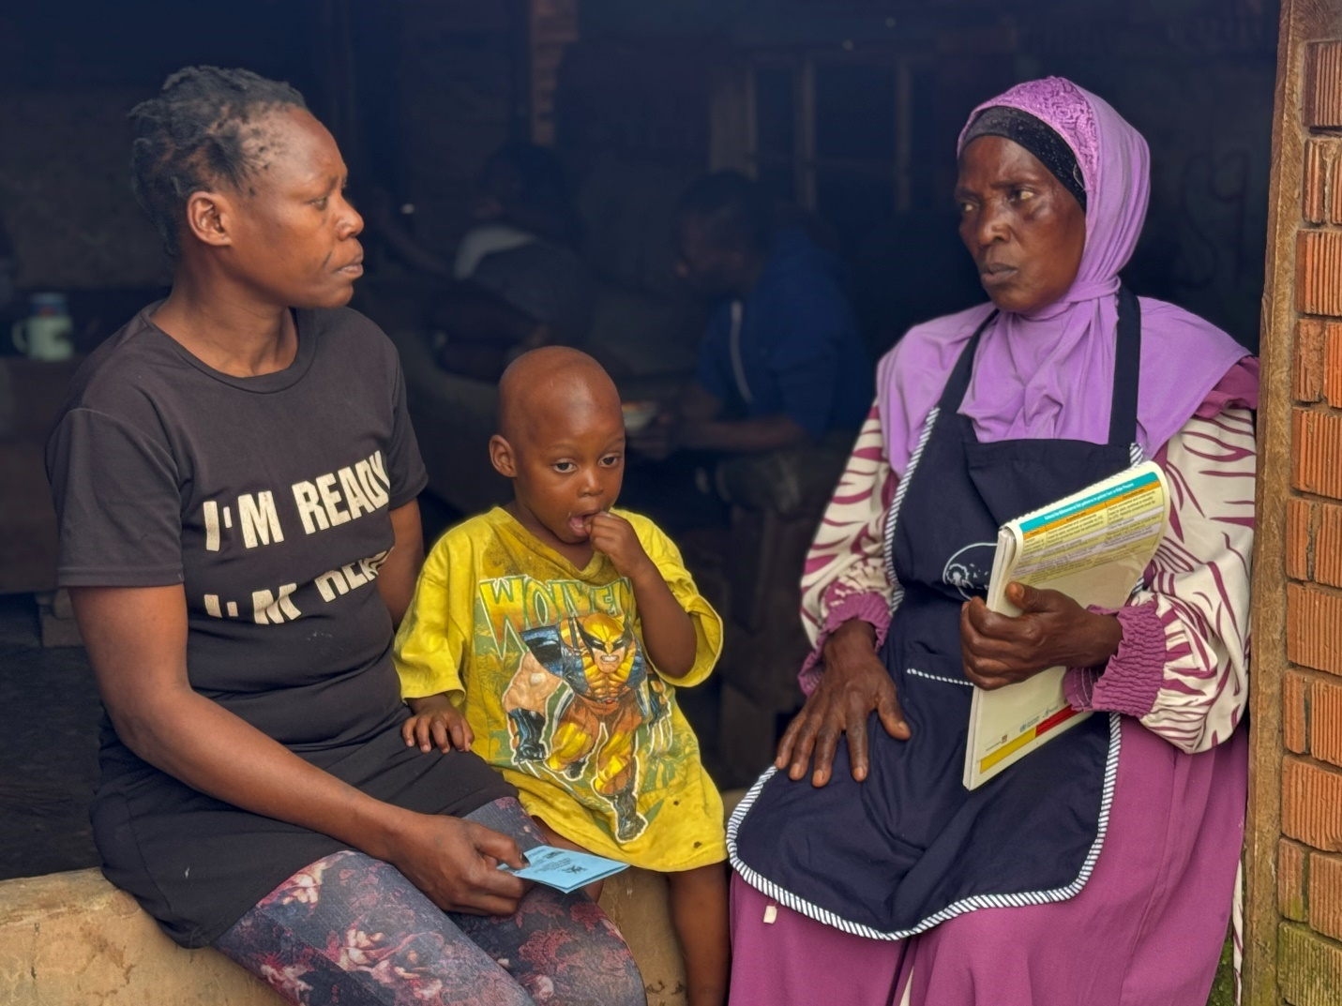

**Mission**:

Advancing socioeconomic outcomes for vulnerable communities through optimized resource utilization and social service accessibility.

**Core Values**: use icons next to each core value

Respect

Equity

Collaboration

Transparency

Integrity

**THEMATIC AREAS**

**CHILD HEALTH**

Thrive-Ug project (On-going), Maintain what you already have on it, and the pictures I sent you. Use only the good quality ones, remove the blurry ones I had sent u first. 6 are enough, symmetrically arranged

**NUTRITION AND FOOD SECURITY:**

Community sensitisation through outreaches, door-to-door health education and home visits, peer club meetings, community dialogues, home based care, identification and referral of clients in need of institutionalised care, radio talk shows and partnering with other CSOs for stronger community engagement.

[Insert photos from last website with outreaches, and door to door visits, around 6 photos max]

**DIVERSITY REACH-OUT:**

To ensure inclusion of diverse identities, we prioritize active engagement with various community groups and incorporate their perspectives add needs into our work, seen through our targeted health outreaches aimed at reaching people with disabilities, to bridge the access gap they face in accessing health facilities.

[Insert photos you have at the top of the website, specifically showing some people with disabilities. Again use about only 4 touching photos]

Below on the contact section, only attach icon links to phone (+256709613795) and email for now. I will update you with linkedin info when I create one

**CAPACITY BUILDING AND TECHNICAL ASSISTANCE:**

Through needs-based trainings and transformative community dialogue, our team of diverse professionals equips community resource persons with the skills and knowledge to drive positive change and serve their communities effectively

The photos above are enough, don’t add collage section